UGC Minor Research Project Report

Title of the Project: Synthesis and characterisation of metal
oxide nanoparticles and their application in
storage technology.

Principal Investigator : Dr.Geeta Nair
Department of Physics, K.J.Somaiya College of Science and Commerce, Mumbai-400077

Co- Investigator Ms. Smita Survase
Department of Physics, K.J.Somaiya College of Science and Commerce, Mumbai-400077

UGC- Minor Research Project (2012-14)

Synthesis and characterisation of metal oxide nanoparticles and their application in storage technology

General background:
The last decade has seen nanotechnology as an important and exciting field which encompasses the branches of physics, chemistry, biology and engineering. Thus, it is a rapidly growing field based on interdisciplinary science. With the development of nanomaterials and nanotechnology, more and more efforts have been directed toward large-scale synthesis of nanoparticles due to their potential applications in many areas. In such uses, nanoparticles with different purity, size, shape and structure will greatly influence the ultimate performance of the devices, and therefore, large scale preparation of nanoparticles with desired quality and low cost by convenient method is of great importance.
Nanomaterials have attracted interest in the past decade and have been studied extensively because of their size and shape dependent physical-chemical and magnetic properties for applications in various useful technologies. In recent years, with growing interest in building advanced materials using nanoscale particles, there is a need for general approach to controlling the size and shape of nanocrystals [1, 2]. Nanoscale metal materials have attracted much attention owing to their promising potential in magnetic storage, magnetic fluid, medical diagnosis and catalysis. Small metal particle arrays have been used to build single-electron devices [2-4]. More attention has been attracted on nanoscale magnetic transition metal-based materials, including Ni, Co and Fe duo to their magnetic properties and application potential. For such crystallites, the physical and chemical properties depend sensitively on particle size and shape [2-11]. In the last few years, nickel nanomaterials with the following shapes have been synthesized: nanotubes, nanorods, hollow spheres, nanobelts, nanoprisms, and hexagonal flakes [2-6].Magnetic nanoparticles are being widely used in rechargeable batteries [7],optoelectronics [8], chemical catalysts [9], conducting paints [10], magnetic recording media, ferro-fluids, magnetic resonance imaging contrast enhancement, drug delivery[11] and magnetic hyperthermia [12, 13]. Several methods have been developed to synthesize particles with controlled size and shape. These methods include photolytic reduction [14], radiolytic reduction [15], sonochemical method [16], solvent extraction reduction [17], microemulsion technique [18], polyol process [19], and chemical route [20].
In recent years, there has been an increasing interest in the synthesis of nano-sized metal oxides because of their large surface area, unusual adsorptive properties, surface defects, and fast diffusivities and the nano materials have extensively attracted interests for their small and quantum-size effects. Nano materials can exhibit novel and significant mechanical, electronic, magnetic, and optical properties in comparison with their bulk counterparts. Several methods (mechanical or chemical) have been used and developed for preparation of crystalline oxide powder in nanoscale dimensions. In many of them, the main objective is to reduce the costs of chemical synthesis and to produce materials for technological applications.
The purpose of this study is to synthesize metal oxide nanoparticles by simple chemical route and to study its applications in storage devices.
In the course of this project, we have synthesized nickel oxide, zinc oxide and titanium oxide nanoparticles.

Nickel Oxide:
Nickel oxide is an insulator that crystallizes in a rocksalt structure. It has excellent chemical stability and shows p-type conductivity due to Ni vacancies and/or O interstitials. It is a semitransparent material and has a wide band gap in the range of 3.5 to 4.3 eV . Nickel oxide (NiO) is a very important material extensively used in catalysis, battery cathodes, gas sensors, and magnetic materials. NiO catalyst exhibits good low temperature catalytic performance for oxidative dehydrogenation of ethane (ODHE) to ethylene reaction. In addition, nickel oxide thin films are very interesting for a variety of applications, For instance, as active material in chemical gas sensors, as anode in oxygen fuel cells, as counter electrode in smart windows due to its p-type electrochromic property, and in other optoelectronic devices such as elements for information display, light shutter and variable reflectance mirrors.

Zinc Oxide:
Zinc oxide (ZnO), a representative of II–VI semiconductor compounds, is a technologically important material. ZnO has a unique position among the semiconducting oxides due to its piezoelectric and transparent conducting properties, high electrical conductivity and optical transmittance in the visible region. These properties make it ideal for applications like transparent conducting electrodes in flat panel displays and window layers in thin film hetero junction solar cells. Due to these properties combined with its low cost and nontoxicity ZnO has been recognized as a promising alternative material to transparent conducting indium tin oxide (ITO). ZnO has a wide band gap (3.37 eV) and a large exciton binding energy (60 meV), exhibiting many potential applications in areas such as laser diodes, gas sensors, optoelectronic devices and devices for solar energy conversion. The ZnOnanostructures are found to have potential application in nano devices such as nano gas sensor. ZnO in the form of nanostructures would enhance the gas-sensing properties of gas sensors due to its high surface area. Apart from this, bio-safe characteristics of ZnO make it very attractive for biomedical applications. A method for economical mass production and determination of conditions favorable for the synthesis of ZnO nanostructures would therefore be very useful. This is why the study of synthesis of ZnO nanostructures and understanding the ZnO nanostructures is of great interest

Titanium Oxide:
Titanium belongs to d block,period IV while oxygen belongs to p block, period II of the periodic table. It is a wide gap semiconductor, whose bandgap can be can be engineered by doping. Titanium oxide is also known as flamenco, rutile, titanium dioxide and dioxotitanium. Titanium oxide nanoparticles are known for their ability to inhibit bacterial growth and prevent further formation of cell structures. Titanium oxide nanoparticles appear in the form of black hexagonal crystals. Titanium oxide exhibits good photo catalytic properties, hence is used in antiseptic and antibacterial compositions. It is used in making of cosmetic products such as sunscreen creams, whitening creams, morning and night creams, skin milks, etc. It is used in manufacture of printing ink, self-cleaning ceramics and glass, coating, etc

Experimental Techniques:
The characterization of the synthesized nanoparticles was carried out using X ray diffraction, Scanning electron microscopy and Ellipsometry. The basics of these techniques is described here.

X-ray powder diffraction (XRD)

Introduction:
X-ray powder diffraction (XRD) is a rapid analytical technique primarily used for phase identification of a crystalline material and can provide information on unit cell dimensions. Max von Laue, in 1912, discovered that crystalline substances act as three-dimensional diffraction gratings for X-ray wavelengths similar to the spacing of planes in a crystal lattice. X-ray diffraction is now a common technique for the study of crystal structures and atomic spacing. X-ray diffractometers consist of three basic elements: an X-ray tube, a sample holder, and an X-ray detector.
Theory:
X-ray diffraction is based on constructive interference of monochromatic X-rays and a crystalline sample. These X-rays are generated by a cathode ray tube, the rays are filtered to obtain monochromatic radiation. After collimation, they are directed toward the sample. The interaction of the incident rays with the sample produces constructive interference (and a diffracted ray) when conditions satisfy Bragg's Law (nλ=2d sin θ). This law relates the wavelength of electromagnetic radiation to the diffraction angle and the lattice spacing in a crystalline sample. These diffracted X-rays are then detectedby the detector.. By scanning the sample through a range of 2θ angles, all possible diffraction directions of the lattice should be attained due to the random orientation of the powdered material. These peaks are then converted to d-spacings. Since each mineral has a set of unique d-spacings, minerals present in the sample can be identified. Typically, this is achieved by comparison of d-spacings with standard reference patterns.
X-rays are generated in a cathode ray tube by heating a filament to produce electrons, accelerating the electrons toward a target by applying a voltage, and bombarding the target material with electrons. When electrons have sufficient energy to dislodge inner shell electrons of the target material, characteristic X-ray spectra are produced. These spectra consist of several components, the most common being K_{α} and K_{β}. K_{α} consists, in part, of K_{α1} and K_{α2}. K_{α1} has a slightly shorter wavelength and twice the intensity as K_{α2}. The specific wavelengths are characteristic of the target material .K_{α1}and K_{α2} are sufficiently close in wavelength such that a weighted average of the two is used. Copper is the most common target material for single-crystal diffraction, with CuK_{α} radiation = 1.5418Å. These X-rays are collimated and directed onto the sample. As the sample and detector are rotated, the intensity of the reflected X-rays is recorded. When the geometry of the incident X-rays impinging the sample satisfies the Bragg Equation, constructive interference occurs and a peak in intensity occurs. A detector records and processes this X-ray signal and converts the signal to a count rate which is then given to output device.
The geometry of an X-ray diffractometer is such that the sample rotates in the path of the collimated X-ray beam at an angle θ while the X-ray detector is mounted on an arm to collect the diffracted X-rays and rotates at an angle of 2θ. The instrument used to maintain the angle and rotate the sample is termed a goniometer. For typical powder patterns, data is collected at 2θ from ~5° to 70°, angles that are preset in the X-ray scan.
X-ray powder diffraction is most widely used for the identification of unknown crystalline materials. It is used in identification of fine-grained minerals such as clays and mixed layer clays that are difficult to determine optically, to determine unit cell dimensions and measure sample purity. It can also be used to determine the orientation of grains, in a polycrystalline sample . It can also estimate the thickness, roughness and density of the film using glancing incidence X-ray reflectivity measurements.
- Scanning Electron Microscopy
Introduction:
The scanning electron microscope (SEM) uses a focused beam of high-energy electrons to generate a variety of signals at the surface of solid specimens. The electrons interact with the sample and this is used to derive information about the sample like morphology (texture), chemical composition, and crystalline structure and orientation of materials making up the sample. A 2-dimensional image is generated that displays spatial variations in these properties. The SEM is also capable of performing analyses of selected point locations on the sample; this is used in qualitative determination of chemical compositions crystalline structure, and crystal orientations.

Theory:
Accelerated electrons in an SEM carry significant amounts of kinetic energy. When such an electron interacts with a sample, they are decelerated in the solid sample. These signals include secondary electrons , backscattered electrons, diffracted backscattered electrons, photons, visible light), and heat. Secondary electrons and backscattered electrons are commonly used for imaging samples: secondary electrons are most valuable for showing morphology and topography on samples and backscattered electrons are most valuable for illustrating contrasts in composition in multiphase samples. Incident electrons undergo inelastic collision with the orbital electrons . As the excited electrons return to lower energy states, they yield X-rays that are of a fixed wavelength. Thus, characteristic X-rays are produced for each element. SEM analysis is considered to be "non-destructive"; that is, x-rays generated by electron interactions do not lead to volume loss of the sample, so it is possible to analyze the same materials repeatedly.
The essential components of SEMs include electron Source , electron lenses, sample stage, detectors , display devices. Apart from this various infrastructure requirements like power supply, vacuum system, cooling system, vibration-free floor etc are essential for SEM.Electromagnetic lenses are used to control the path of the electrons. The condenser defines the size of the electron beam while the objective lens focuses the beam onto the sample. Scanning coils are used to raster the beam onto the sample.
Figure shows the schematic representation of SEM
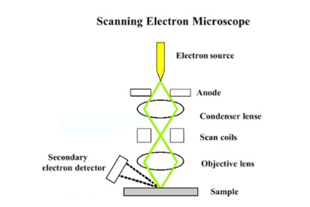
(Fig: https://serc.carleton.edu/research_education/geochemsheets/techniques/SEM.html)

Different types of electrons are emitted from samples upon interacting with the electron beam. A BackScattered Electron (BSE) detector is placed above the sample to help detect backscattered electrons. Images show contrast information between areas with different chemical compositions as heavier elements (high atomic number) will appear brighter. A Secondary Electron (SE) detector is placed at the side of the electron chamber, at an angle, in order to increase the efficiency of detecting secondary electrons which can provide more detailed surface information.
- Ellipsometry :
Introduction:
Ellipsometry is an optical technique which is used to determine the dielectric properties (complex refractive index or dielectric function) of thin films. It measures the change of polarization upon reflection or transmission and compares it to a model.
Ellipsometry measures a change in polarization as light reflects or transmits from a material structure. The polarization change is represented as an amplitude ratio, Ψ, and the phase difference, Δ. The measured response depends on optical properties and thickness of individual materials. Thus, ellipsometry is primarily used to determine film thickness and optical constants. However, it can also be used to characterize doping concentration, composition, roughness, electrical conductivity, and other material properties. It is very sensitive to the change in the optical response of incident radiation that interacts with the material being investigated.
Since the 1960s, interest in ellipsometry has grown steadily as the sensitivity of the technique improved to measure nanometer-scale layers used in microelectronics,. Today, ellipsometry is used in the basic research in physical sciences, communication,semiconductorand data storage solutions, biosensor, and optical coating industries. This widespread use is explained by increased dependence on thin films in many areas and the flexibility of ellipsometry to measure most material types: dielectrics, semiconductors, metals, superconductors, organics, biological coatings, and composites of materials.
Theory:
Light can be described as an electromagnetic wave traveling through space.. The electric field of a wave is always orthogonal to the propagation direction. Therefore, a wave traveling along the z-direction can be described by its x- and y- components. When the light has completely random orientation and phase, it is considered unpolarized. Ellipsometry requires waves in specific phase and orientation which is known as polarized light. When two orthogonal light waves are in-phase, the resulting light will be linearly polarized. The relative amplitudes determine the resulting orientation. If the orthogonal waves are 90° out-of-phase and equal in amplitude, the resultant light is circularly polarized. The most common polarization is “elliptical”, one that combines orthogonal waves of arbitrary amplitude and phase.
Electromagnetic radiation is emitted by a light source and linearly polarized by a polarizer. It passes through an optional compensator and falls onto the sample. After reflection the radiation passes a compensator (optional) and a second polarizer, which is called an analyzer, and falls into the detector. The angle of incidence equals the angle of reflection. Hence ellipsometry is a specular optical technique. The incident and the reflected beam map the plane of incidence. Light which is polarized parallel to this plane is named p-polarized (p-polarised). A polarization direction perpendicular to the above is called s-polarized (s-polarised).

The figure below shows a schematic representation of ellipsometry.
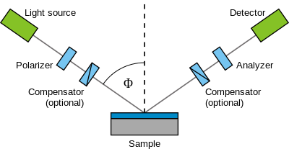

(Fig:https://www.jawoollam.com/resources/ellipsometry-tutorial/what-is-ellipsometry)

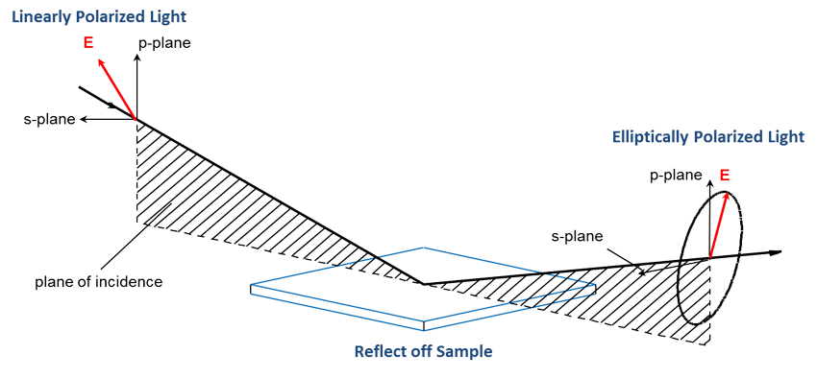
(Fig:https://www.jawoollam.com/resources/ellipsometry-tutorial/what-is-ellipsometry)

Maxwell’s equations must be satisfied when light interacts with a material, which leads to boundary conditions at the interface. Incident light will reflect and refract at the interface, as shown in the figure below. The angle between the incident ray and sample normal (θ_{i}) will be equal to the reflected angle, (θ_{r}).

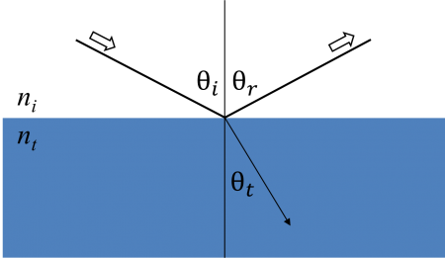
.
Light entering the material is refracted at an angle θ_{t} given by:

$$n_{i}sinθ_{i}=n_{t}sinθ_{t}$$
$$r_{p}=\frac{E_{rp}}{E_{ip}}=\frac{n_{t}cosθ_{i}-n_{i}cosθ_{t}}{n_{t}cosθ_{i}+n_{i}cosθ_{t}}$$

$$t_{p}=\frac{E_{tp}}{E_{ip}}=\frac{2n_{i}cosθ_{i}}{n_{t}cosθ_{i}+n_{i}cosθ_{t}}$$

$$r_{s}=\frac{E_{rs}}{E_{is}}=\frac{n_{i}cosθ_{i}-n_{t}cosθ_{t}}{n_{i}cosθ_{i}+n_{t}cosθ_{t}}$$

$$t_{s}=\frac{E_{ts}}{E_{is}}=\frac{2n_{i}cosθ_{i}}{n_{i}cosθ_{i}+n_{t}cosθ_{t}}$$

Thin film and multilayer structures involve multiple interfaces, with Fresnel reflection and transmission coefficients applicable at each interface. The film phase thickness is defined as
$$β=2π\frac{d_{1}}{λ}n_{1}cosθ_{1}$$
The superposition of multiple light waves introduces interference that depends on the relative phase of each light wave.
Ellipsometry studies as how p- and s- components change upon reflection or transmission in relation to each other. A known polarization is reflected or transmitted from the sample and the output polarization is measured. The change in polarization is the ellipsometry measurement. It is given by
$$ρ=tanψe^{iΔ}$$

The film thickness is determined by interference between light reflecting from the surface and light traveling through the film. Depending on the relative phase of the waves interference can be defined as constructive or destructive. The interference involves both amplitude and phase information. The phase information from Δ is very sensitive to films down to sub-monolayer thickness. Upon the analysis of the change of polarization of light, ellipsometry can yield information about layers that are thinner than the wavelength of the probing light itself, even down to a single atomic layer. Ellipsometry can probe the complex refractive index or dielectric function tensor.
Usually, ellipsometry is done only in the reflection setup. The exact nature of the polarization change is determined by the sample's thickness, complex refractive indexor function.Ellipsometryuses phase information (polarization state), and can achieve sub-nanometer resolution. Ellipsometry is typically used for films whose thickness ranges from sub-nanometers to a few microns. As films become thicker than several tens of microns, interference oscillations become increasingly difficult to resolve. In such case longer infrared wavelengths have to be used. Therefore ellipsometry is not preferred for thicker samples. In its simplest form, the technique is applicable to thin films with thickness of less than a nanometer to several micrometers. Most models assume the sample is composed of a small number of discrete, well-defined layers that are optically homogeneous and isotropic.

Annexure 1
Brief Objective of the Project:
The objective of the work is to synthesize metal oxide nanoparticles by simple chemical route. The chemical synthesis method is the most versatile, reproducible and non expensive method as compared to other synthesis techniques. The main idea is to produce atoms in solution. These atoms then collapse into nanoparticles. Then the use of surfactant is made to attain uniformity in the size. After the surfactant sticks to the nanoparticles their further growth is stopped. Hence we can control the size of the nanoparticles. We can also use the surfactant selectively to give a particular shape to these particles. The study also aims to compare different metal oxide nanoparticles in terms of their particle size and shape. It is also proposed to study the use of these particles in storage devices.
In the present work, we synthesized nickel oxide, titanium oxide and zinc oxide nanoparticles by chemical method. The chemical synthesis which follows the bottom to top method i.e building the nanoparticles from their molecular species becomes a powerful tool to reproduce the nanoparticles in macroscopic amount. The chemical synthesis is the most versatile, reproducible and nonexpensive procedure compared to all other methods. The main idea is to produce atoms in solution. These atoms then collapse into nanoparticles. Then the use of surfactant is made to attain uniformity in the size. After the surfactant sticks to the nanoparticles their further growth is stopped. Hence we can control the size of the nanoparticles. We can also use the surfactant selectively to give a particular shape to these particles.

Annexure II

Summary of findings:
The metal oxide nanoparticles were prepared using the following procedure.

Methodology:
All the samples were prepared using AR grade chemicals without further purification.

Preparation of NiO nanoparticles:

55 mg of nickel acetate was dissolved in 1-propanol. 250 mg of PVP was dissolved to obtain a solution. The solution was then heated in a round bottom flask. 5 mg of palladium acetate was injected to the solution under constant stirring. The solution turned black indicating formation of Ni nanoparticles. The precipitate of Ni was dissolved in 40 ml of octylamine and nickel acetyl acetonate. The solution was refluxed for 5 hours and the particles were collected by centrifugation.

Preparation of ZnO nanoparticles

0.9 m aqueous solution of NaOH was taken I a round bottom flask and heated upto 550C. To this solution, 0.45 M Zn (No3)2 solution was added dropwise under continuous stirring. The solution was kept overnight . The precipitate was washed in DI water to obtain white coloured ZnO nanoparticles.

Preparation of TiO₂nanoparticles:

20 ml of titanium trichloride was added to a round bottom flask and 60 ml of 0.1 M ammonium hydroxide solution was added to it. The solution was stirred at room temperature . The formation of nanoparticles is indicated by white colour solution. The solution was centrifuged and the precipitate was washed with DI water and dried at room temperature to obtain TiO₂ nanoparticles.

Characterisation:

X-ray Diffraction:

The samples were characterised by X-ray Diffraction (XRD). X-ray powder diffraction was collected on a Philips X –ray diffractometer tube with monochromatiser Cu Kα (1.5406 A⁰) with a scan range of 5 to 60 degrees and step size of 0.05 degree. The average thickness of the sample was determined using the Debye- Scherrer formula. Also the strain and dislocation density were estimated.
Fig below shows the XRD pattern of NiO and ZnO nanoparticles.
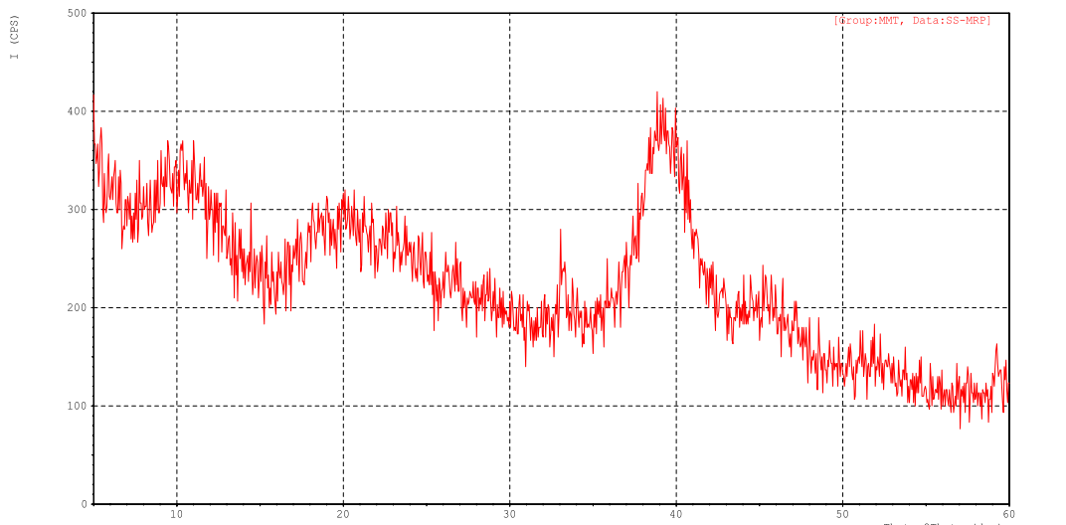
Fig 1. XRD of NiO

The XRD pattern clearly shows an intense peak at 39 degrees. Comparison with the standard database confirms the presence of Ni [010] hexagonal nanoparticles. (CAS 7440-02-0).
The particle size was estimated using the Debye- Scherrer formula

D= $\frac{0.94λ}{βcos}$

Where D is the particle size, λ is the wavelength of light used and θ is the scattering angle.
The size of the nanoparticles was found to be around 30 nm.

The strain calculation was done using the Stokes Wilson formula ε= β/4tanθ and the dislocation density was estimated using δ=15ε/aD

The strain was found to be 9.1x10⁻³ and the dislocation density was found to be 1.86x10¹⁶/m²

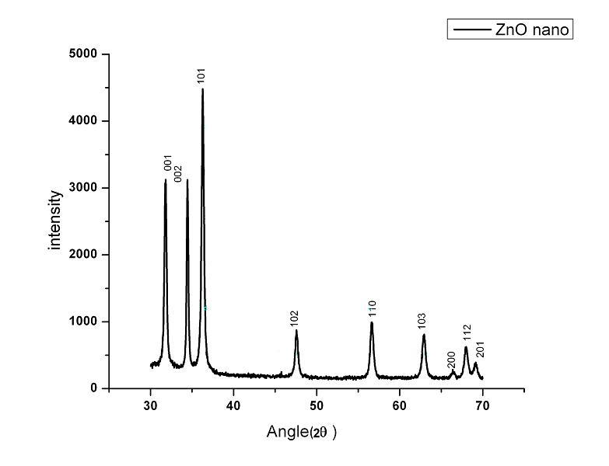
Fig.2 XRD pattern of ZnO

Ellipsometry:

The sample was also characterized using ellipsometry. The variation of refractive index with wavelength at various glancing angles was studied using ellipsometry. ( Model no. M-2000).

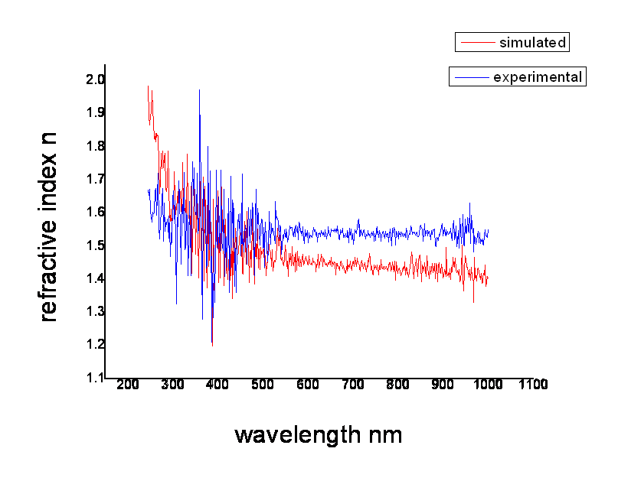
Fig.3 Refractive index against wavelength

Fig 3.shows the experimental and calculated curve of refractive index with varying glancing angle. The result shows a good agreement of experimental data with the theoretical fit.
The graph shows dispersion in refractive index with a peak around 400nm.
Also the maximum refractive index is at 1.9, which is different from that of the bulk Ni, which is 1.08

.

References:

- C.M. Lieber, Solid State Communications 107 (1998) 607.
- V.F. Puntes, K.M. Krishnan, A.P. Alivisatos, Science, 291 (2001) 2115.
- Y. Hou, S Gao, J. of Materials Com. Chem., 13 (2003)1510.
- S. Sun, C.B. Murray, D.Weller, L. Folks and A.Moser, Science, 287 (2000)1989.
- C.C. Chen, A. B. Herhold, C. S. Johnson, A. P. Alivisatos, Science, 276 (1997) 398.
- Z. Liu, S. Li, Y. Yang, S. Peng, Z. Hu and Y. Qian, Adv. Mater., 22 (2003) 1946.
- E. Antolini, M. Ferretti and S. Gemme, J. Mater. Sci. 31(1996) 2187.
- L.L. Beecroft and C.K. Ober,Chem. Mater. 9 (1997)1302.
- L.N. Lewis, Chem. Rev. 93 (1993) 2693.
- H. Eisazadeh., G. Spinks, and GG Wallace, Mater Forum, 17 (3) (1993) 241.
- H.T.Zhang ,G.Wu, X.H.Chen, X.G.Qiu, Materials Research Bulletin 41 (2006) 495.9
- M. Bettge, J Chatterjee and Y. Haik, BioMagnetic Research and Techn. (2004), 2:4
- K.Okawa, M.Sekine, M.Maeda, M.Tada, M.Abe, N.Matsushita, K.Nishio and H.
Handa, J. Appl. Phys. 99, (2006) 08H102.
- S. Remita, M. Mostafavi and M.O. Delcourt, Radiat. Phys. Chem. 47 (1996) 275.
- J.H. Hodak, A. Henglein, M. Giersig and G.V. Hartland, J. Phys. Chem. B. 104
(2000) 11708.
- Y. Mizukoshi, K. Okitsu, Y. Maeda, T.A. Yamamoto, R. Oshima and Y. Nagata, J.
Phys. Chem. B. 101 (1997) 7033.
- M. Brust, M. Walker, D. Bethell, D.J. Schiffrin and R. Whyman, J. Chem. Soc.
Chem. Commun. 7 (1994) 801.
- D.H. Chen and S.H. Wu, Chem. Mater. 12 (2000) 1354.
- L.K. Kurihara, G.M. Chow and P.E. Schoen, Nanostruct. Mater. 5 (1995) 607.
- J. Y. Choi, K. Y. Lee, B.K. Kim and J. M. Kim, J.Am.Ceram.Soc.,88 [11] (2005)
3020.
- Cullity, B. D. 1978. Elements of X-ray diffraction. 2nd ed. Addison-Wesley, Reading, Mass.
- Klug, H. P., and L. E. Alexander. 1974. X-ray diffraction procedures for polycrystalline and amorphous materials. 2nd ed. Wiley, New York.
- Moore, D. M. and R. C. Reynolds, Jr. 1997. X-Ray diffraction and the identification and analysis of clay minerals. 2nd Ed. Oxford University Press, New York.
- Goldstein, J. (2003) Scanning electron microscopy and x-ray microanalysis. Kluwer Adacemic/Plenum Pulbishers, 689 p.
- Reimer, L. (1998) Scanning electron microscopy : physics of image formation and microanalysis. Springer, 527 p.
- Egerton, R. F. (2005) Physical principles of electron microscopy : an introduction to TEM, SEM, and AEM. Springer, 202.
- Clarke, A. R. (2002) Microscopy techniques for materials science. CRC Press (electronic resource)
- https://serc.carleton.edu/research_education/geochemsheets/techniques/XRD.html
- https://serc.carleton.edu/research_education/geochemsheets/techniques/SEM.html
- https://www.jawoollam.com/resources/ellipsometry-tutorial/what-is-ellipsometr

